**Continuous delivery by using GitHub Actions**

Use [GitHub Actions](https://github.com/features/actions) to define a workflow to automatically build and deploy code to your function app in Azure Functions.

In GitHub Actions, a [workflow](https://docs.github.com/en/actions/learn-github-actions/introduction-to-github-actions#the-components-of-github-actions) is an automated process that you define in your GitHub repository. This process tells GitHub how to build and deploy your function app project on GitHub.

A workflow is defined by a YAML (.yml) file in the /.github/workflows/ path in your repository. This definition contains the various steps and parameters that make up the workflow.

For an Azure Functions workflow, the file has three sections:

| **Section** | **Tasks** |
| --- | --- |
| **Authentication** | Download a publish profile. Create a GitHub secret. |
| **Build** | Set up the environment. Build the function app. |
| **Deploy** | Deploy the function app. |

**Architectural Diagram**

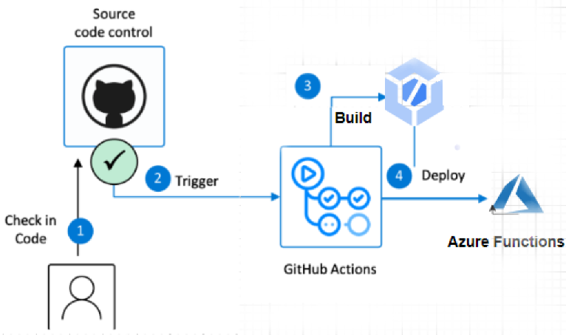

**Implementation :**

### Step 1 - Login to Azure Subscription using Microsoft Account.

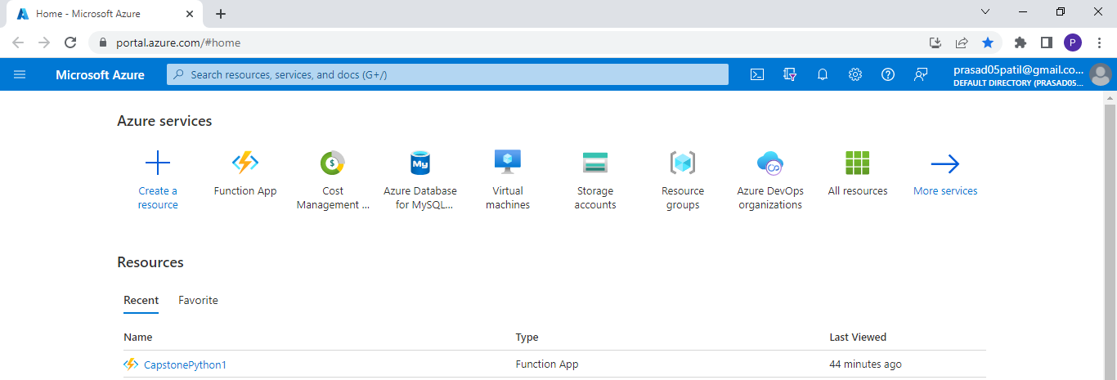

### Step 2 – Login to GitHub account and push the Function App to Github Repository.

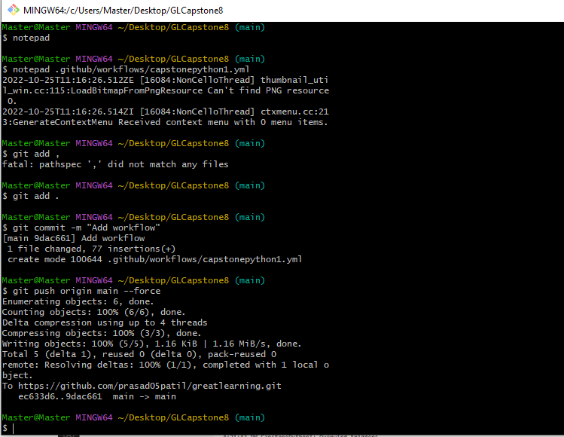

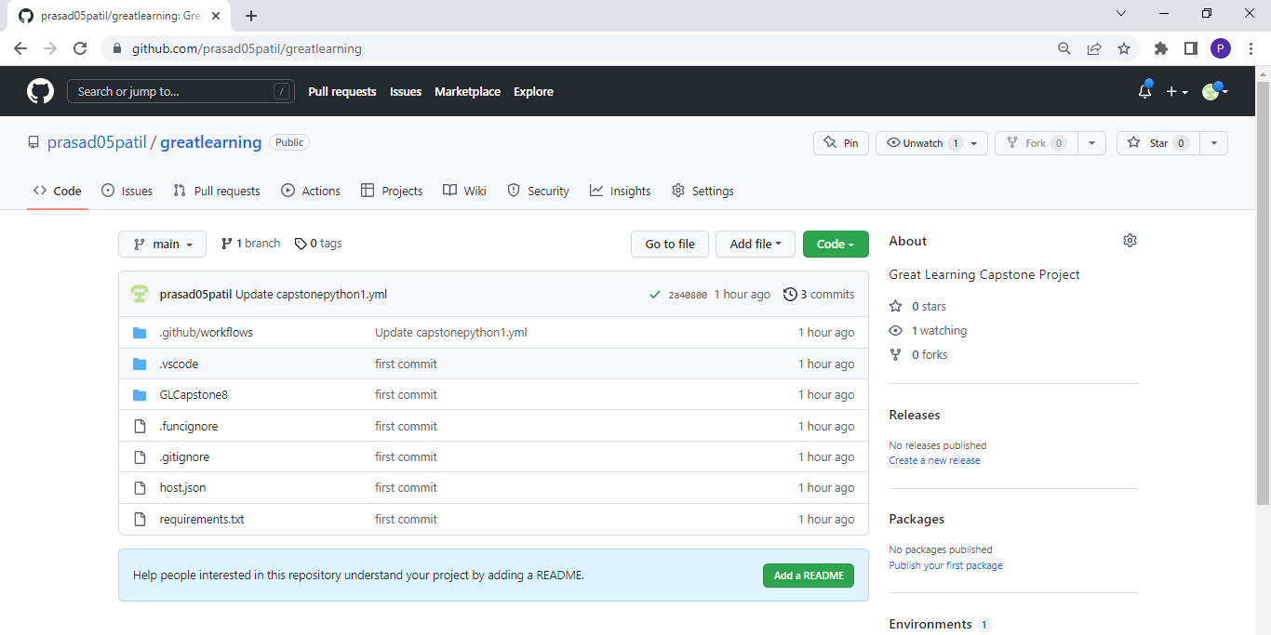

### Step 3 – Create working function app using Visual Studio

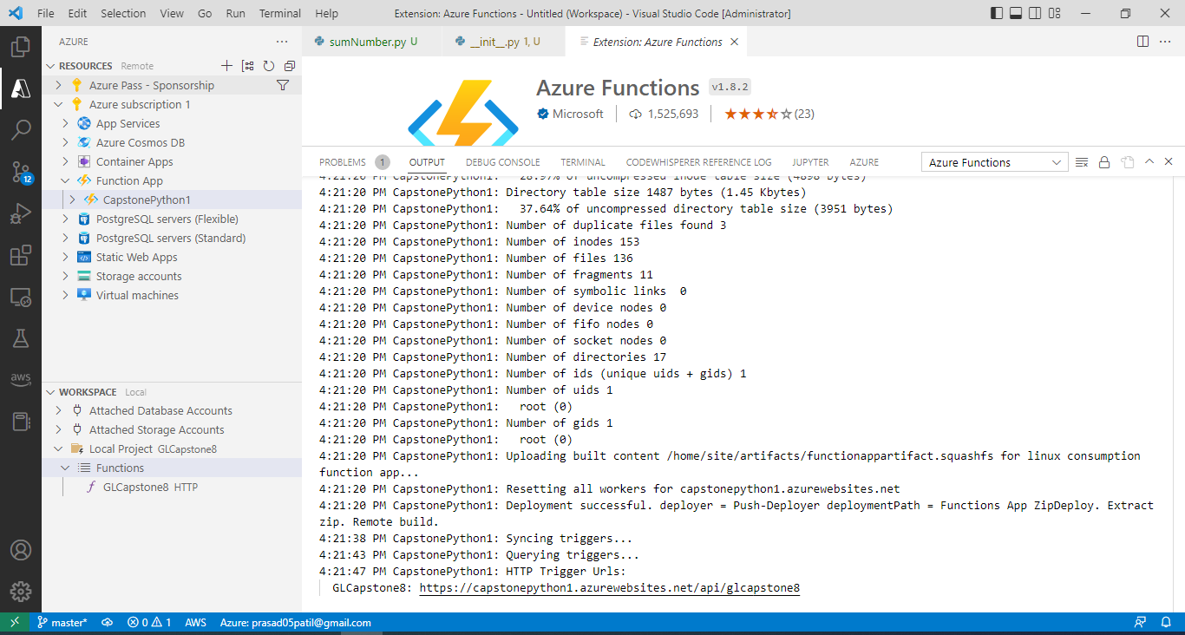

### Step 4 – Trigger the Function using HTTP Trigger to verify if the function is active and running :

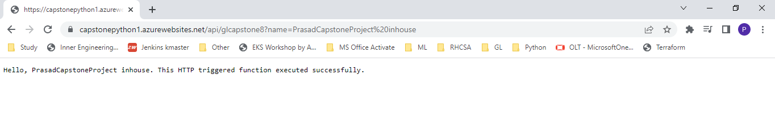

### Step 5 – Verify function deployed using Visual studio Code in Azure Portal :

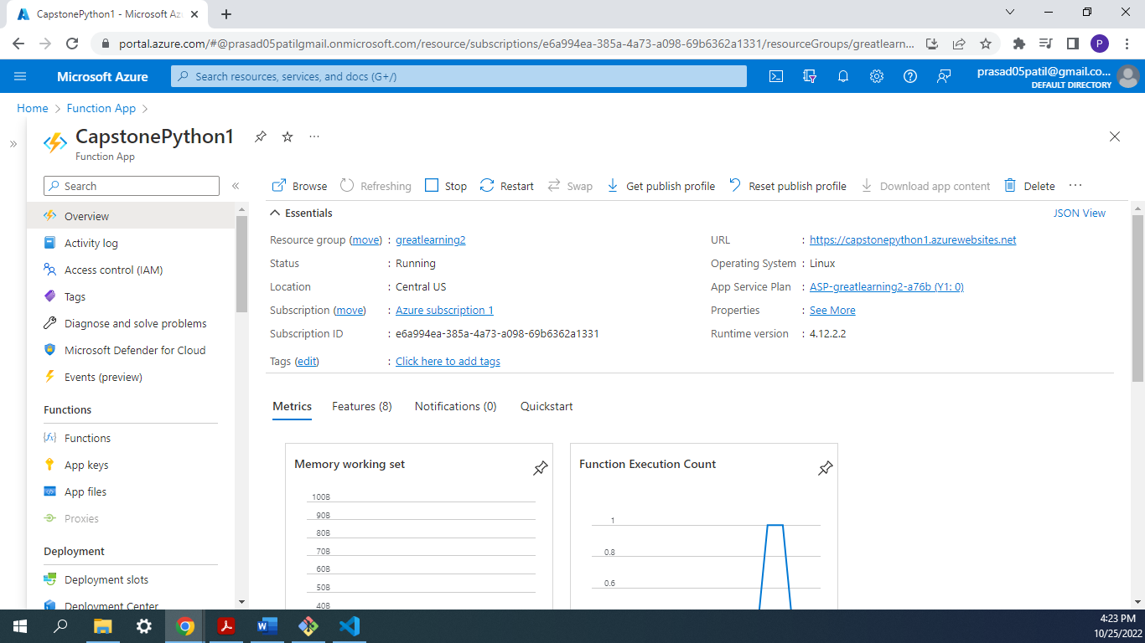

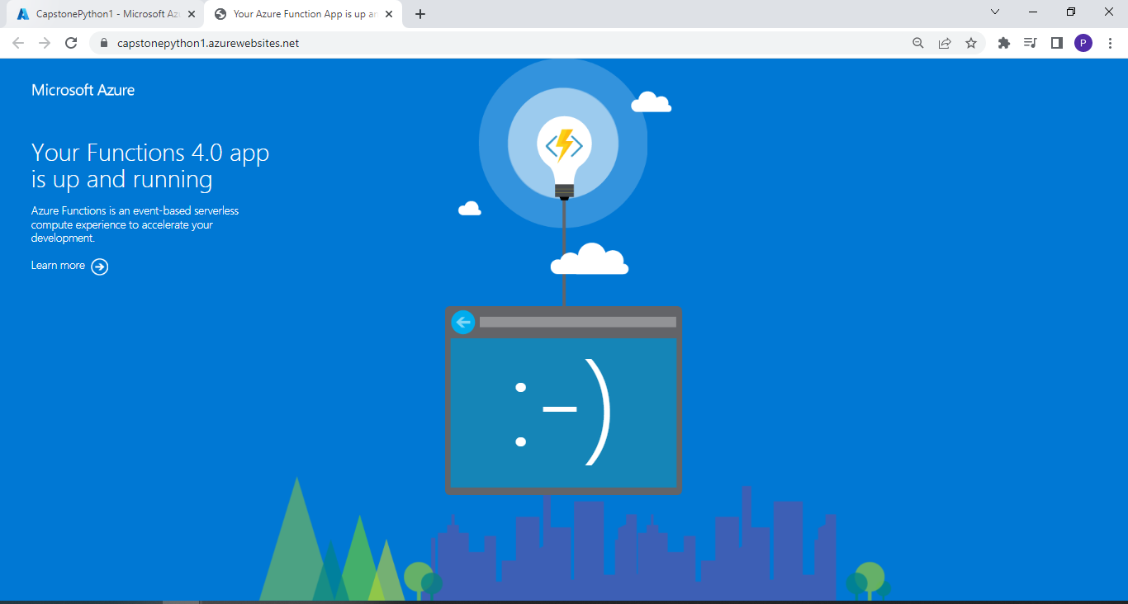

### Step 6 – Download your publish profile of Azure function to integration with Github

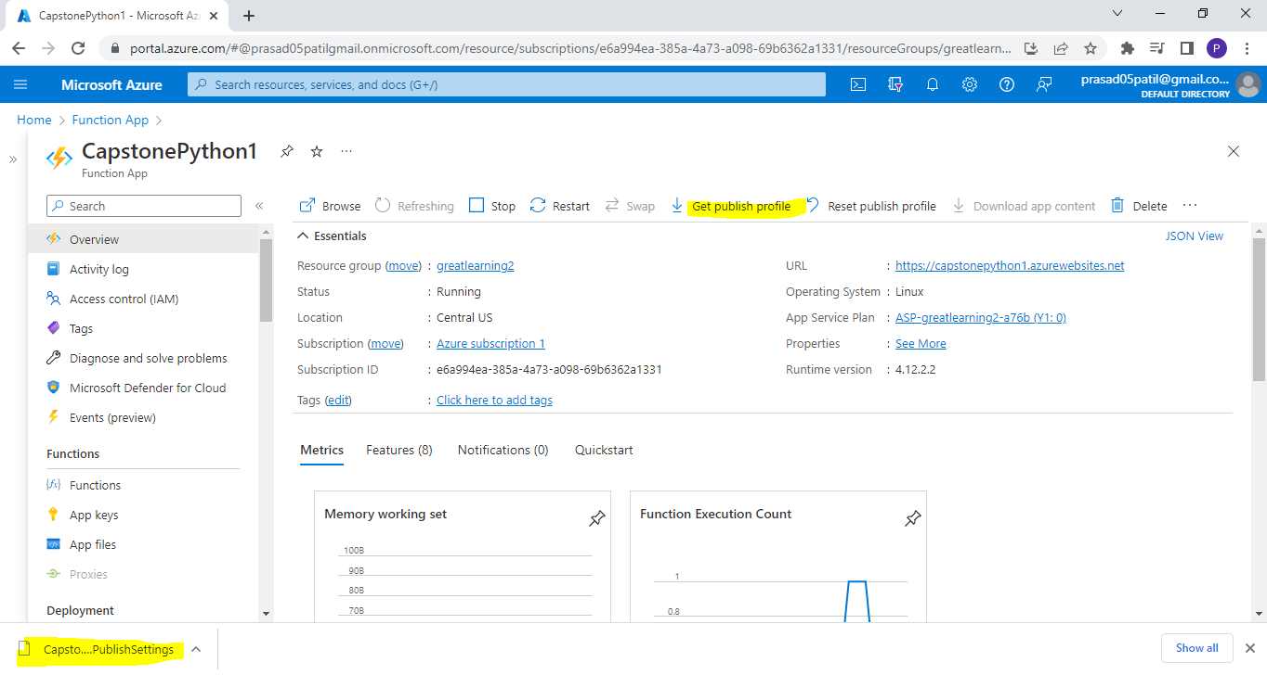

### Step 7 – Add the GitHub secret and add Publish Settings as secrets :

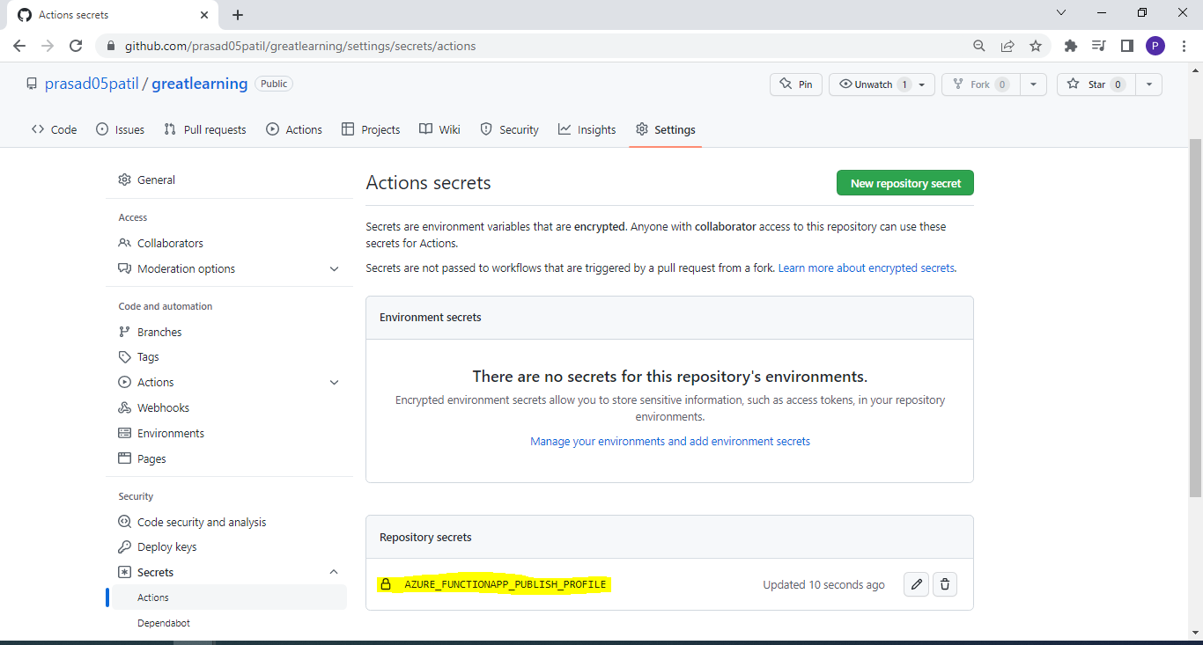

## Step 8 – Create the Github Actions Workflow YAML File :

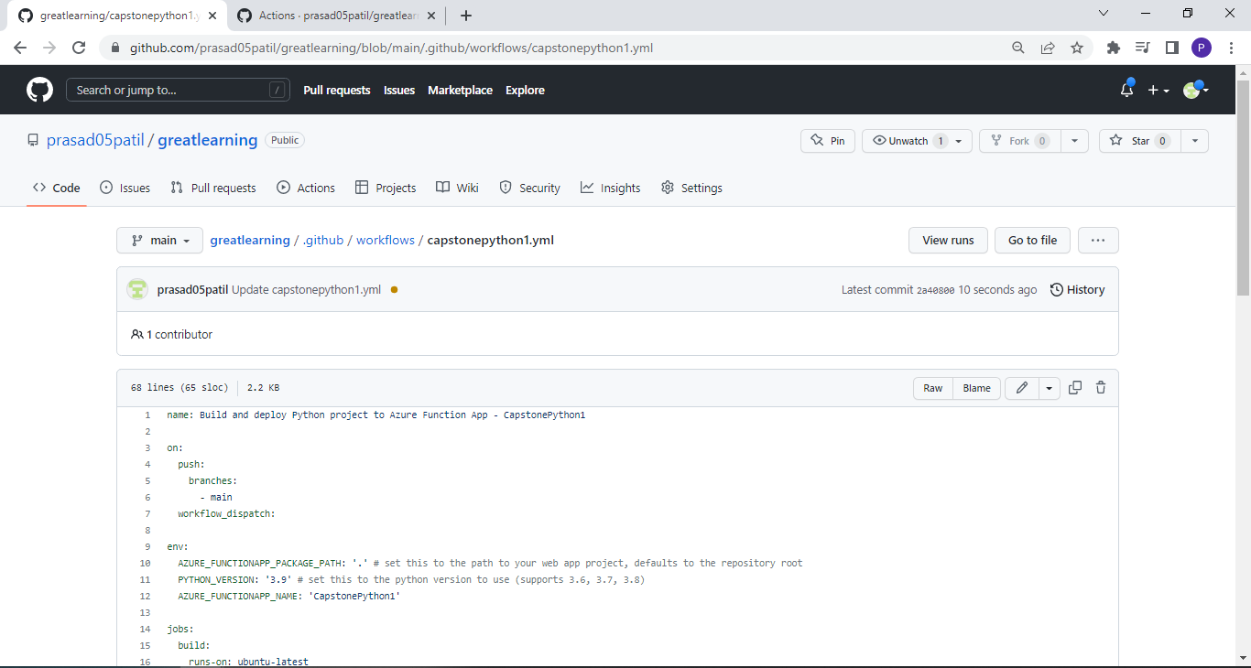

## Step 9 – Modify YAML file with Build definitions for building function app

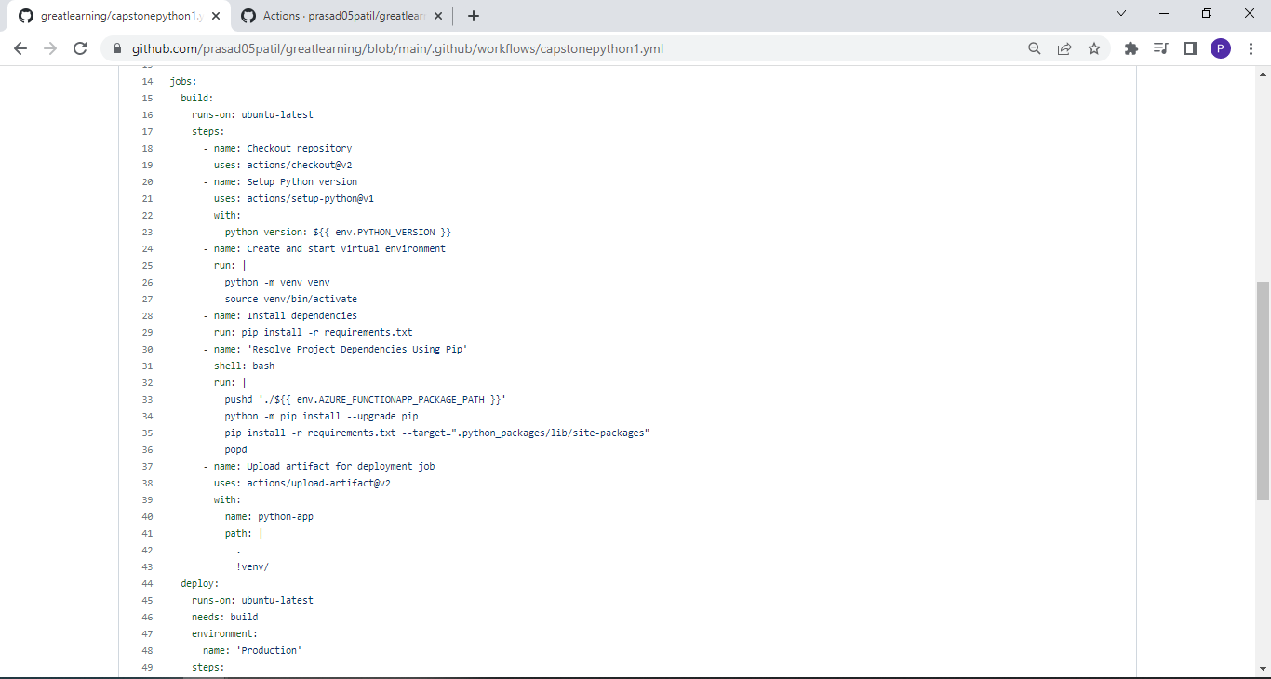

## Step 10 – Modify YAML file with Deploy definitions for Deploying the function app

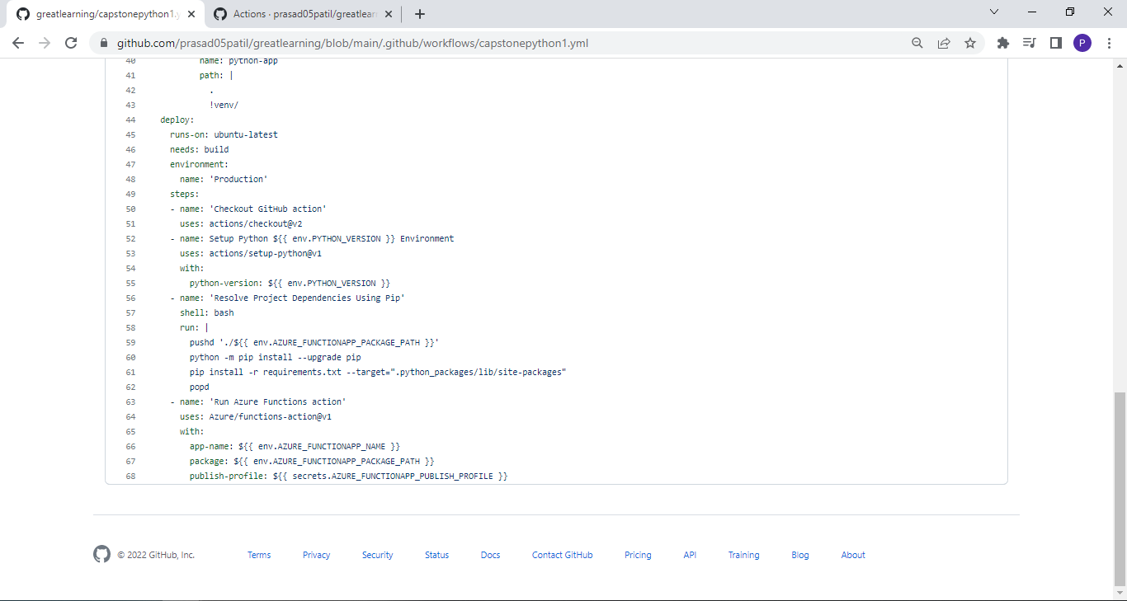

## Step 11 - Execute Final Github Workflow for Publishing the complete Build and Deploy flow :

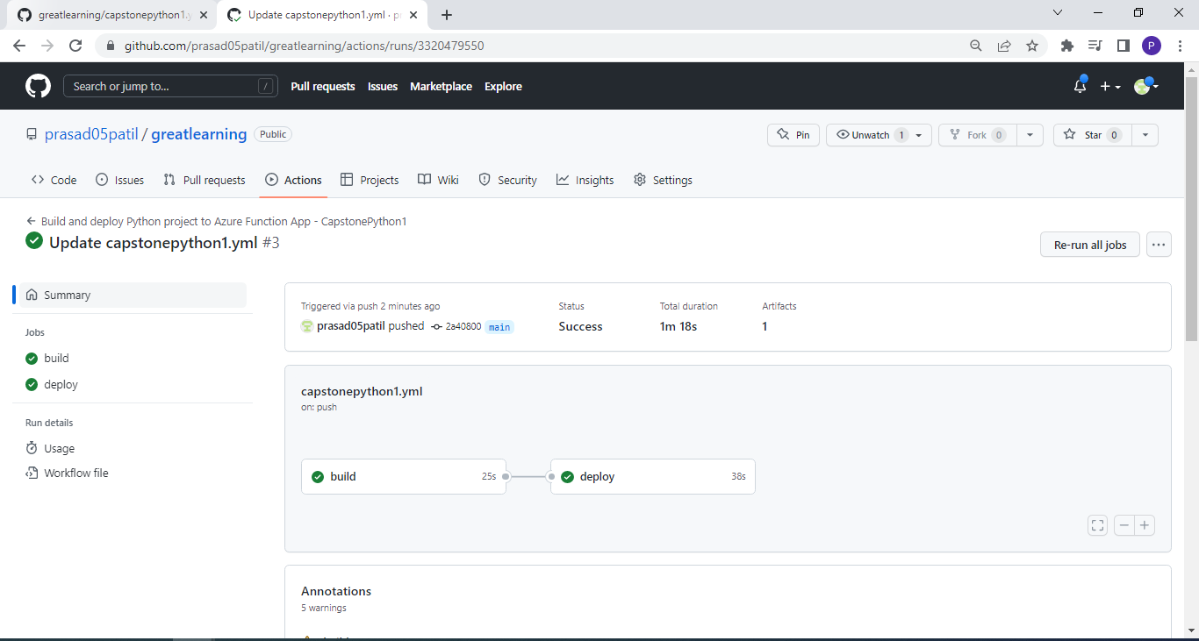

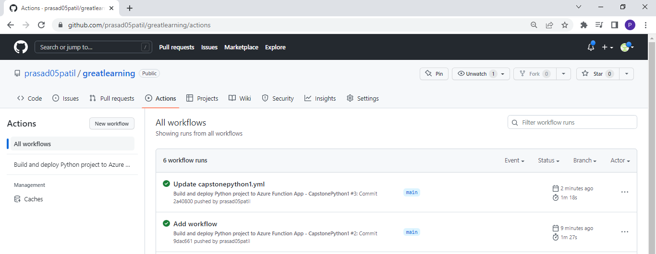

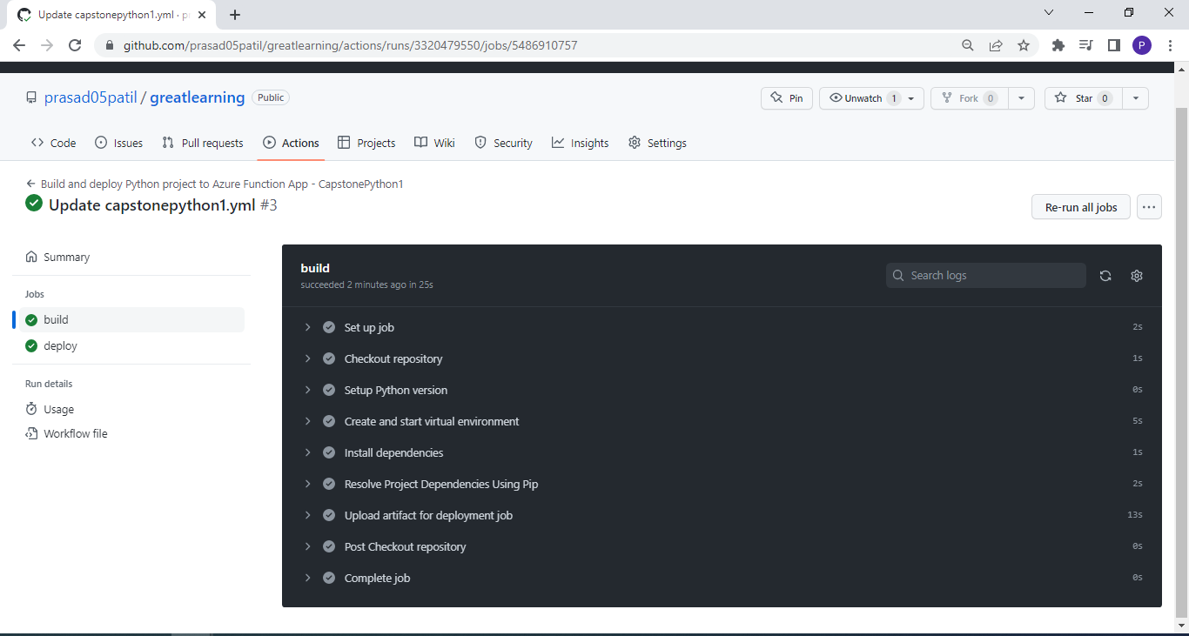

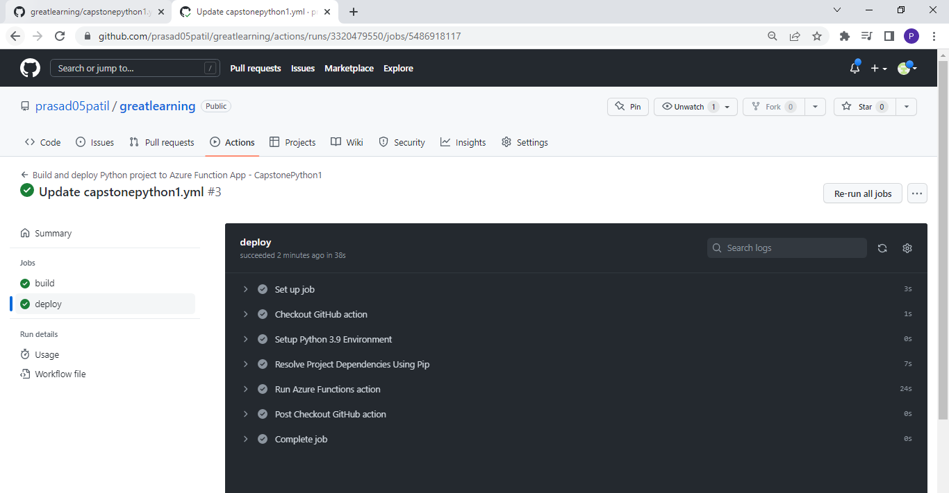

**Cost Analysis**

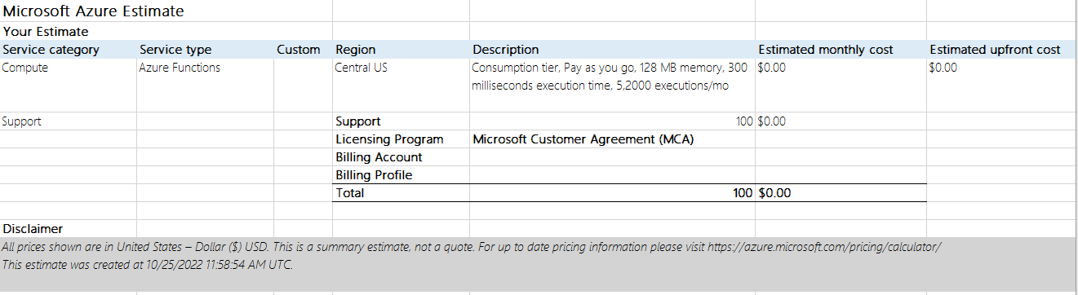

Github Pricing :

